Notes – Ubuntu Setup for Front-end Dev

Expression – Calculation and output Values
Statement - Action

In shell terminal
sudo apt update
sudo apt upgrade
Downdload Vscode apt
Download NERD FONT , choose FiarCode FiraCodeNerdFont-Regular and install
sudo apt install zsh
sudo apt install curl
sudo apt install git -y
Go to Chrome setup oh my zsh
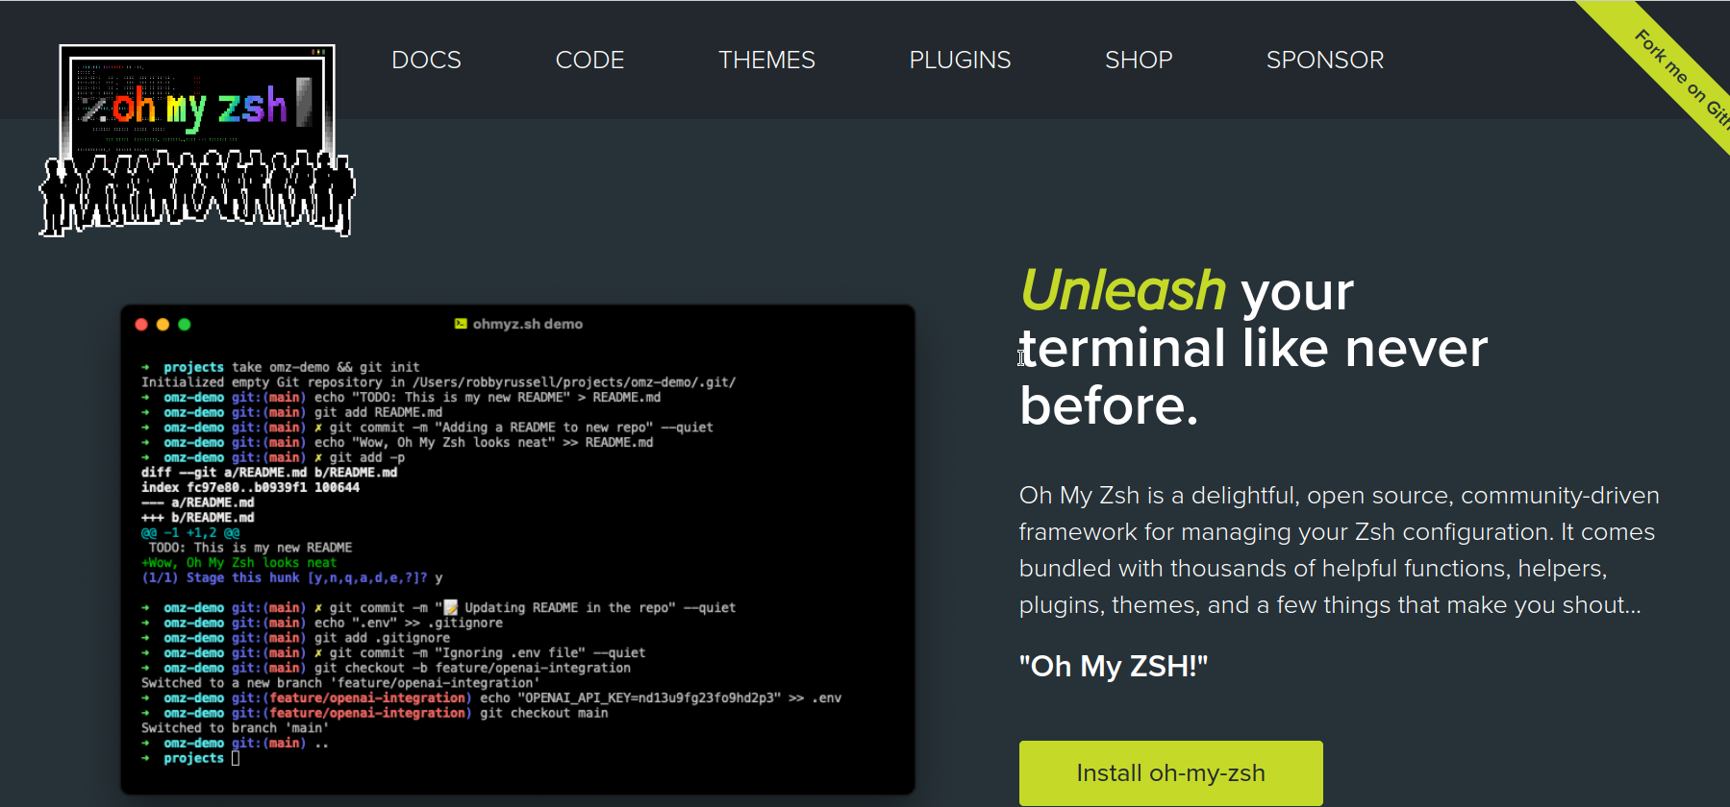sudo
sh -c "$(curl -fsSL https://raw.githubusercontent.com/ohmyzsh/ohmyzsh/master/tools/install.sh)"
Install powerlevel9k under oh my zsh
Via Chrome goto github Powerlevel9K
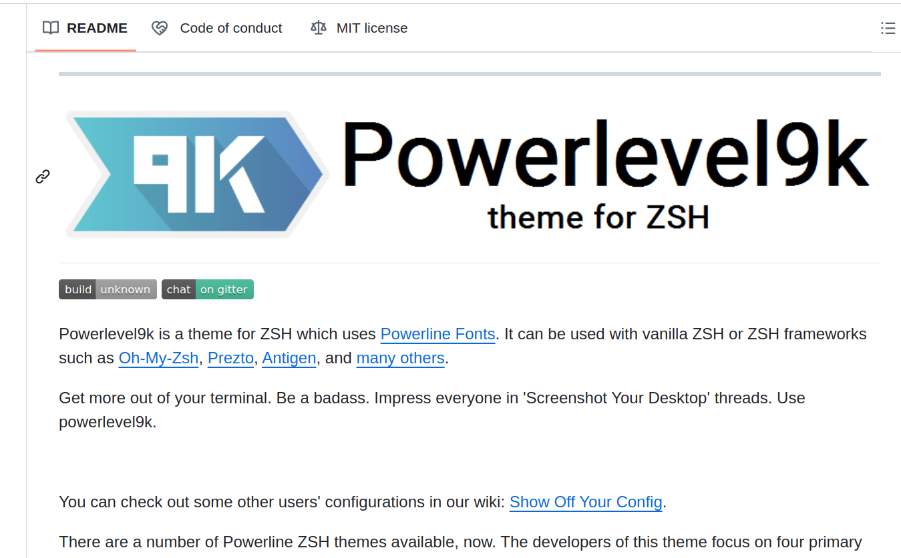
Installation
Install 9KTheme, oh-my-zsh
Option 2sudo

git clone https://github.com/bhilburn/powerlevel9k.git ~/.oh-my-zsh/custom/themes/powerlevel9k

chsh -s $(which zsh) #change zsh as default shell, need sudo reboot to take effect
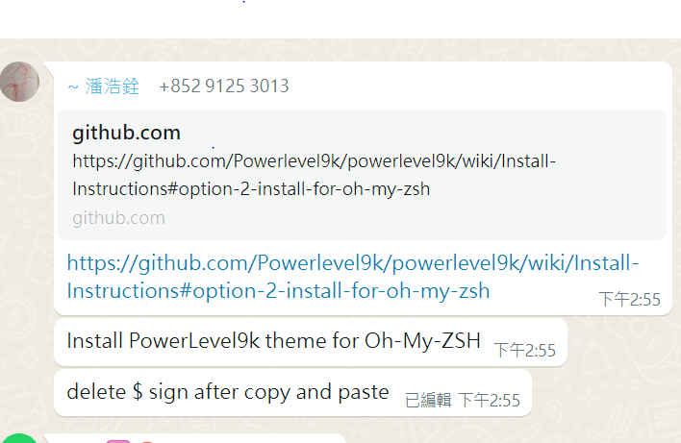

Add the following to the zshcr configuration file
export ZSH="$HOME/.oh-my-zsh"
ZSH_THEME="powerlevel9k/powerlevel9k"
POWERLEVEL9K_PYENV_PROMPT_ALWAYS_SHOW=true
HIST_STAMPS="mm/dd/yyyy"
plugins=(git zsh-autosuggestions zsh-syntax-highlighting virtualenv nvm pyenv vscode)
POWERLEVEL9K_LEFT_PROMPT_ELEMENTS=(dir vcs virtualenv pyenv php_version nvm java_version rust_version rbenv laravel_version)
POWERLEVEL9K_NODE_ICON="\UE718"

source $ZSH/oh-my-zsh.sh
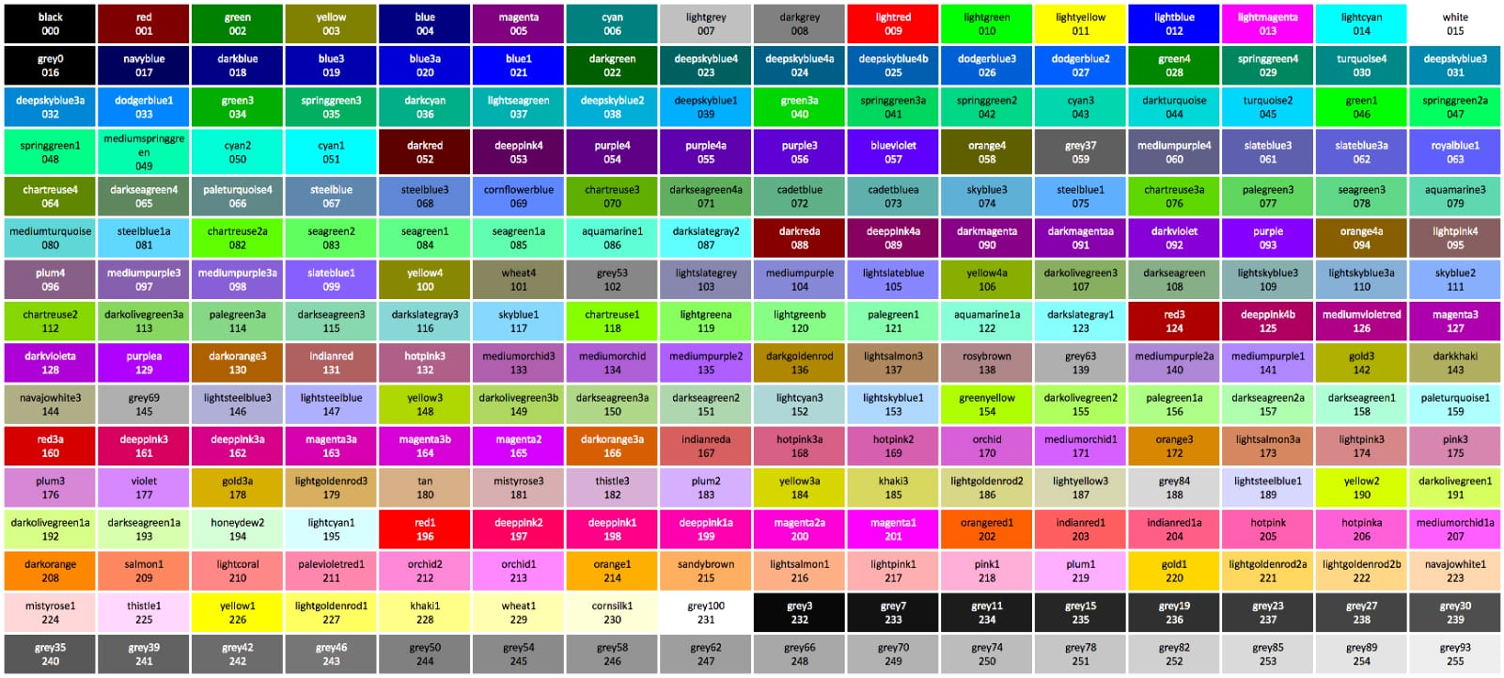
Install pyenv
git clone https://github.com/pyenv/pyenv.git ~/.pyenv
Install pyenv
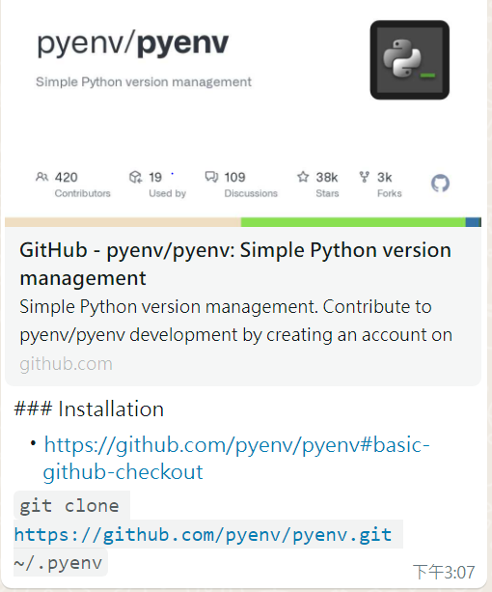
git clone https://github.com/pyenv/pyenv.git ~/.pyenv

Use style.css for storing css code

In HTML there are several semantic elements that can be used to define different parts of a web page:
- <article>
- <aside>
- <details>
- <figcaption>
- <figure>
- <footer>
- <header>
- <main>
- <mark>
- <nav>
- <section>
- <summary>
- <time>

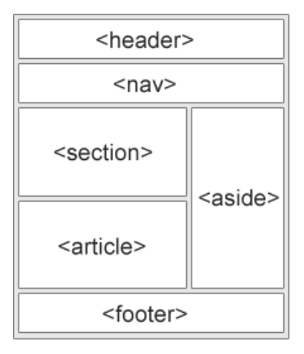

CSS Selector Syntax
Element selector
element {
property: value;
}
e.g. h2 define
h2 {}
<h2> ….. </h2>
Class selector –
.highlight {
background-color: yellow;
font-weight: bold;
}
Class selector define .name {div class=’name’,
ID selector
#header {
font-size: 24px;
color: red;
}
ID selector define #name {div id = ‘name’,
article.pro specify the special case
De

1. Target an Element with a Specific Class
Combine an element selector with a class selector.
Syntax: element.classname { ... }

2. Target an Element with a Specific ID
Combine an element selector with an ID selector.
Syntax: element#idname { ... }

3. Chain Multiple Classes
Target elements with multiple classes (e.g., <div class="box red">).
Syntax: .class1.class2 { ... } (no space between classes).
Only elements with both classes are styled. <div class="box red">Has red border</div>

4. Combine Classes and IDs (Less Common)
You can mix IDs and classes, but IDs are usually specific enough alone.
Syntax: #idname.classname { ... }

5. Group Selectors (Apply Same Styles to Multiple Selectors)
Group Selectors (Apply Same Styles to Multiple Selectors)
Use a comma (,) to group different selectors for the same styles.
Syntax: selector1, selector2, selector3 { ... }

1. Layout & Positioning
display: Controls how an element behaves (e.g., block, flex, grid, inline-block).
position: Sets positioning (e.g., relative, absolute, fixed, sticky).
top / right / bottom / left: Positions elements (works with position).
float: Wraps text around elements (left, right, none).
clear: Stops elements from floating beside others.

2. Flexbox & Grid (Modern Layouts)
Flexbox:
flex-direction (row, column).
justify-content (horizontal alignment).
align-items (vertical alignment).
gap (spacing between items).

Grid:
grid-template-columns / grid-template-rows.
grid-gap (spacing)
grid-area (for named placements).

3. Box Model (Spacing & Sizing)
width / height: Sets dimensions.
margin: Outer spacing (e.g., margin: 10px;).
padding: Inner spacing (e.g., padding: 20px;).
border: Combines border-width, border-style, border-color.
box-sizing: border-box (includes padding/border in width/height).

4. Typography & Text
font-family: Sets the font (e.g., Arial, sans-serif).
font-size: Text size (e.g., 16px, 1.2rem).
font-weight: Boldness (normal, bold, 700).
color: Text color (e.g., #333, rgb(0,0,0)).
text-align: Alignment (left, center, right).
line-height: Spacing between lines.
text-decoration: Underlines/strikethrough (none, underline).

5. Backgrounds & Images
background-color: Fills element background.
background-image: Adds an image (url('image.jpg')).
background-size: Controls scaling (cover, contain).
background-position: Adjusts image position (center, top right).
background-repeat: Prevents tiling (no-repeat).

6. Colors & Transparency
color: Text color.
background-color: Element background.
opacity: Transparency (0.5 = 50% transparent)
**rgba() / hsla(): Colors with alpha (e.g., rgba(255,0,0,0.3)).

7. Transforms & Animations
transform: Moves/scales elements (rotate(45deg), scale(1.2)).
transition: Smooth changes (e.g., transition: all 0.3s ease;).
animation + @keyframes: Complex animations.

8. Pseudo-Classes & States
:hover: Styles on mouse hover.
:active: Styles when clicked.
:focus: Styles when focused (e.g., input fields).
:nth-child(): Targets specific elements in a group.

9. Responsive Design
@media: Media queries for screens (e.g., @media (max-width: 600px) { ... }).
min-width / max-width: Breakpoint conditions.
vw / vh: Viewport units for fluid sizing.

10. Shadows & Effects
box-shadow: Adds shadows (box-shadow: 2px 2px 5px grey;).
text-shadow: Text shadows.
filter: Visual effects (blur(), brightness()).

Short hand in VSCode to type html
p.general-slibing{….}+h4{…..}
li*2

Top 10 Most-Used CSS Properties (Based on Real-World Usage):
color
font-size
margin / padding
background-color
display (especially flex and grid)
width / height
border
text-align
position
transition

ctl / to comment it in vscode

In privilege order

universal selector
* {border: 1px solid red;}
* {letter-spacing: 1px; word-spacing 3px;} for debugging

element selector
p { color: 55EB14;}

class selectors
.simply {color: red;}
.box {color: pink;}
.inner-box {border: 1px solid #ccc}

id selector
#heading {color: blueviolet;}
#unique-box {border: 2px solid black;}

attribute selector
[type=”text”] {border: 2px solid #007bff};

Descendant Selector
element
ul li { color: peru;} # select li first and filter ul
ul.list li.highlight {color: red;}

direct child with

direct child with element
div > h2 {} # > means the first item selected
.box > .child {} # > means the first item selected
div h2 {} (descendant selector) - Targets ALL <h2> inside <div> at any level

div > h2 {} (child selector) - Targets ONLY <h2> that are direct children

multiple class selector
.inner-box.first-box{} # inner-box and first box, not direct child

multiple elements selector
h5, h6 {} # all h5 or h6 will be selected #, means or

multiple classes
multipe1, multiple2 {}

Adjacent sibling selector
div + a {}
.link + .box-sibling {}
.box ~.general-sibling{} # all sibling matching
h1 ~ h4 {} al

color : rgb or rgba (alpha channel) or hsla

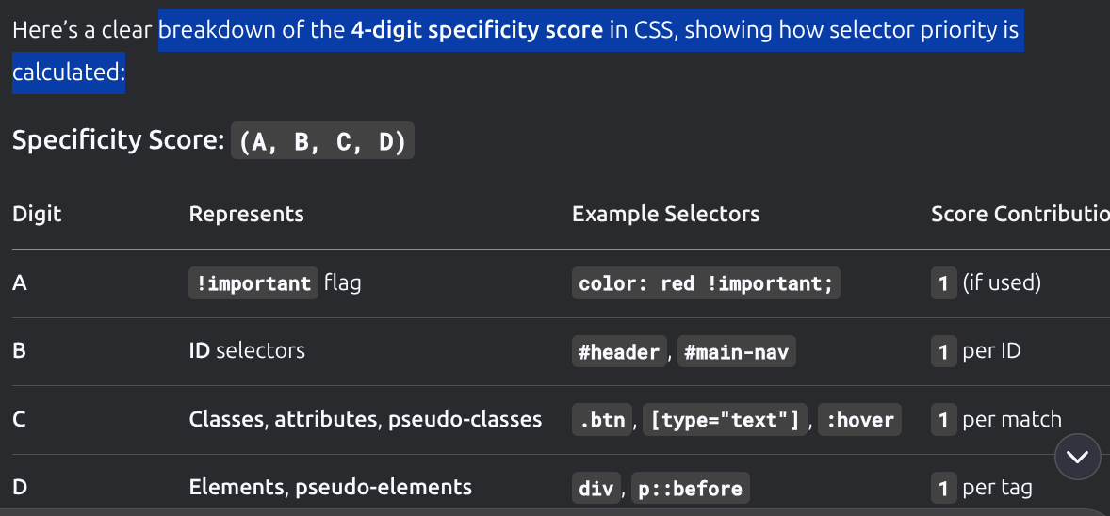

BEM – block element modifier

class name naming convention – Block-element-body
e.g. in Bootstrap

card-body, card-title, card-text, btn btn-primary (modifier)

navbar navbar-expand-lg bg-body-tertiary
container-fluid

id= most related to javascript (change state)

for <a> <a role=’button’.. >

data attribute e.g. data-bs-toggle=”dropdown” data- Variable_name=”value” for javascript

Use fontawesome

padding = spacing between text and container

In apple use orbstack

For power9K use option 2 for oh my zsh
Terminal can remote connect to server, if $=local server # = remote terminal

Install nvm and zshrc
use nvm for node version control

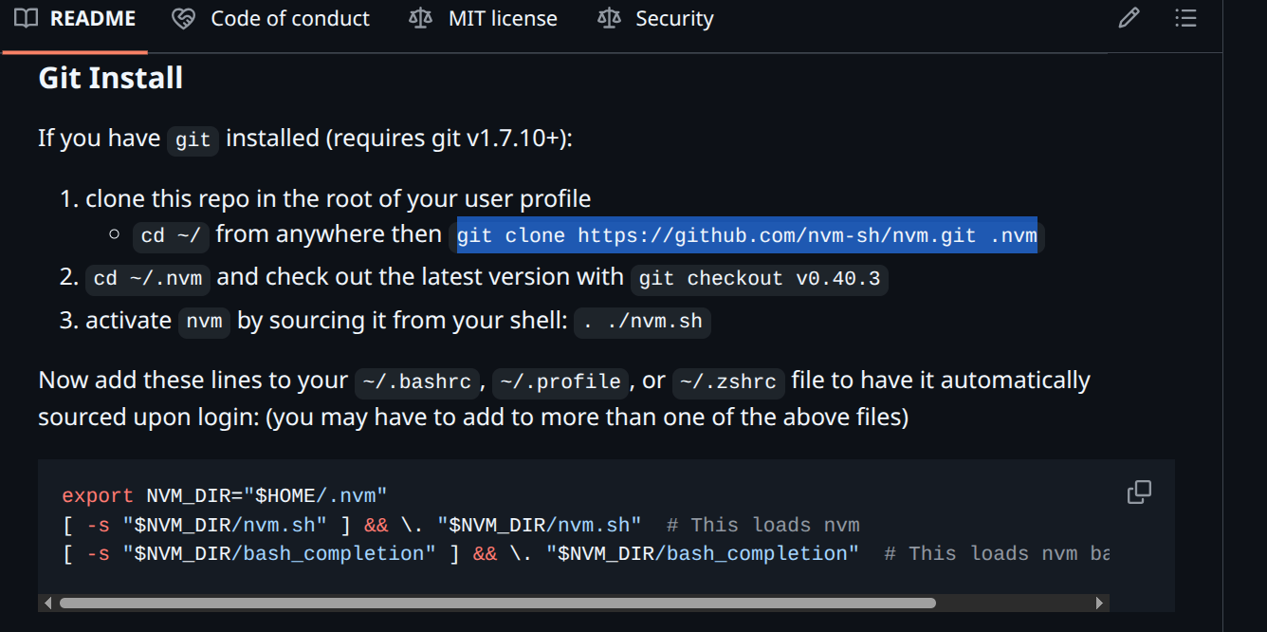
git clone https://github.com/nvm-sh/nvm.git .nvm

Add these lines to zshrc

export NVM_DIR="$HOME/.nvm"
[ -s "$NVM_DIR/nvm.sh" ] && \. "$NVM_DIR/nvm.sh" # This loads nvm
[ -s "$NVM_DIR/bash_completion" ] && \. "$NVM_DIR/bash_completion"
# This loads nvm bash_completion

----------------------------------------------------------------------------------------------------------------------------------------
Install Node Js
nvm use 22.10.0 #only use even version
node -v
nvm ls-remote

nvm install 24.4.1
nvm use 24.4.0
---------------------------------------------------------------------------------------------------------------------------------------

Install virtualenv
sudo apt update
sudo apt install python3-pip
sudo apt install python3-virtualenv
virtualenv –version

Install Python Different Version
In zsh, type
pyenv install 3.12.3
pyenv install 3.12.4
pyenv install 3.12.5 …..

Set the global version of python (mandatory)
pyenv global 3.12.4
pip3 install virtualenvwrapper (need to restart zsh for effect)
Install auto suggestion and syntax checking
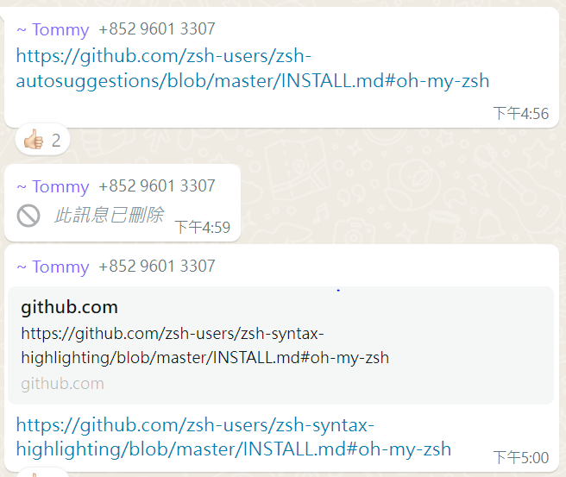ps aux

git clone https://github.com/zsh-users/zsh-autosuggestions.git $ZSH_CUSTOM/plugins/zsh-autosuggestions
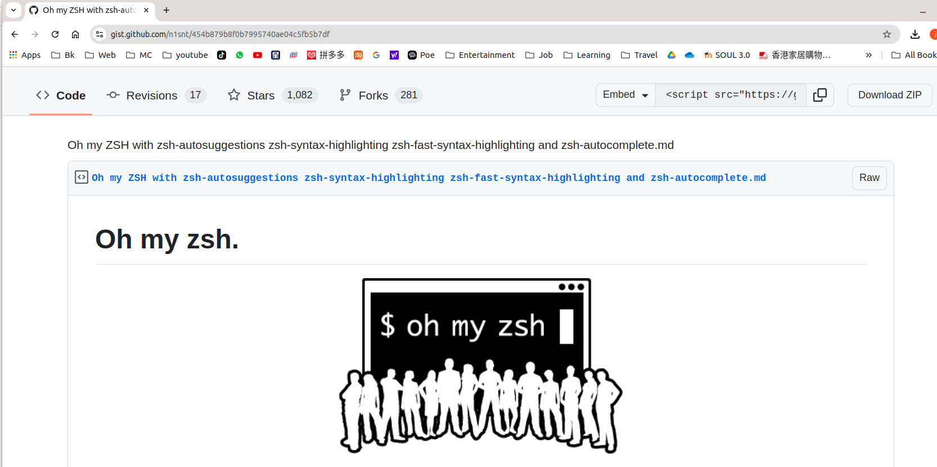
git clone https://github.com/zsh-users/zsh-syntax-highlighting.git $ZSH_CUSTOM/plugins/zsh-syntax-highlighting

Install pyenv virtualenvwapper
for separating the environment for each project
get from github

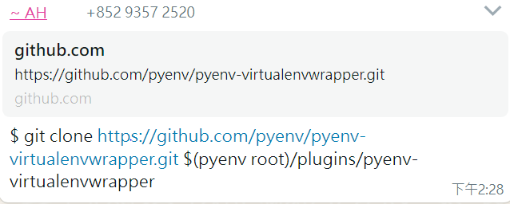

git clone https://github.com/pyenv/pyenv-virtualenvwrapper.git $(pyenv root)/plugins/pyenv-virtualenvwrapper

In zsh, add the following (before the source /. Zsh statement)
prompt_virtualegfnv() {
local virtualenv_path = "$VIRTUAL_ENV"
if [[ -n "$virtualenv_path" &&
"$VIRTUAL_ENV_DISABLE_PROMPT" != true ]]; then (basename "$virtualenv_path")" 'PYTHON_ICON'
"$1_prompt_segment" "$0" "$2" "green" "black" "$

fi
}

At the end of file,
Add
export PYENV_VIRTUALENVWRAPPER_PREFER_PYVENV='true'
export WORKON_HOME=$HOME/.virtualenvs
pyenv virtualenvwrapper_lazy

File of Chuen

Create new virtual environment
In zsh, the mkvirtualenv nameofnew_environment
workon # list environment
workon cshopenv #goto environment
deactivate #leave environment

Set up Git Linkage
In zsh,
Git init
# .gitignore store the information to be skipped by git
Create the Project Directory under Home (say myProject)
Create an account in Github
As below, define user name of Git
In zsh,
git config --global user.name "YourUserName"
git config --global user.email "YourEmail"
git config --global user.name or user.mail # show the name setup in the machine
You should see the setup stored in file
ssh-keygen -t ed25519 -C "your email"
# setup the ssh key for your machindie (cannot be used in other machine
You should see the key stored in file

In Github (windows), user-profile- Settings-SHH and GPG Keys
Cut and paste the key generated – Add the keyssh-ed25519 AAAAC3NzaC1lZDI1NTE5AAAAIOImOG1ylYqdGqD418VgYG7/2N4g0dZXltp8lO7ESbYb jackieng2000@yahoo.com.hk
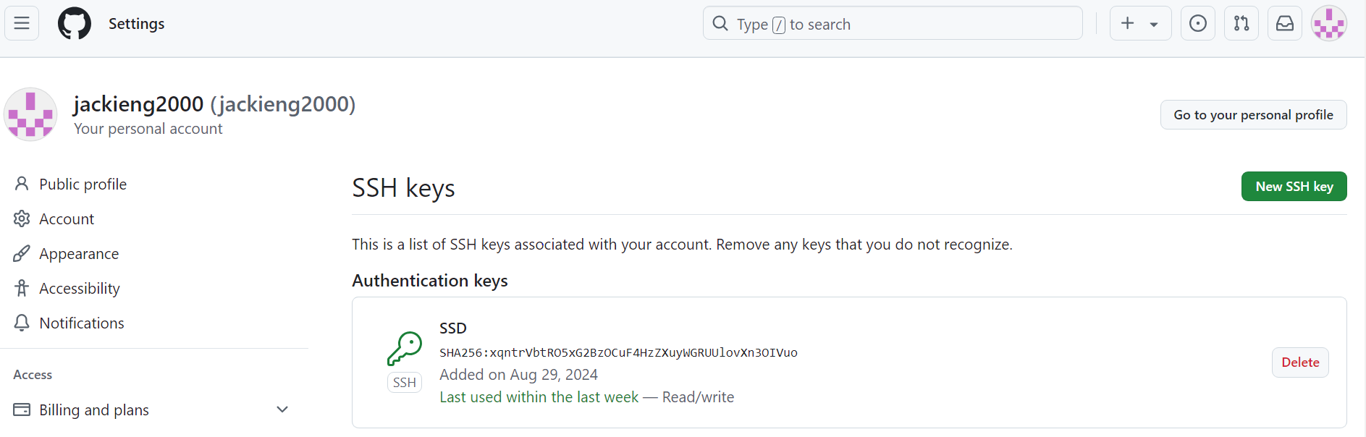

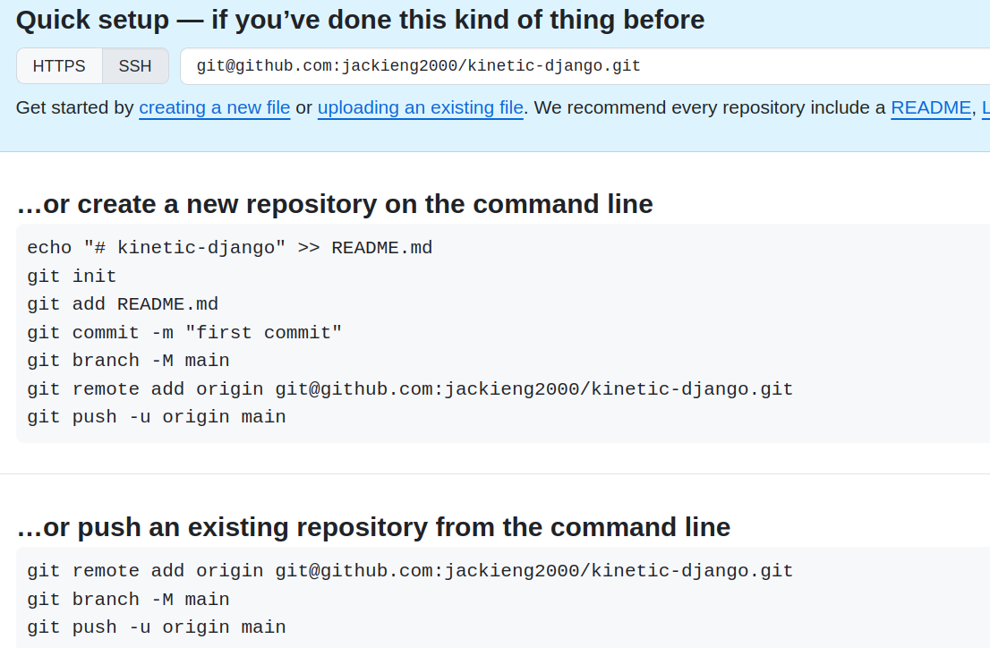
Note: use master instead of main for ubuntussh-ed25519 AAAAC3NzaC1lZDI1NTE5AAAAIOImOG1ylYqdGqD418VgYG7/2N4g0dZXltp8lO7ESbYb jackieng2000@yahoo.com.hk
In zsh,
Git add .cd ~/.ssh
Git commit –m “any message”
Git push –u origin master # update the master file to git
# check the Repository setup in github (windows)
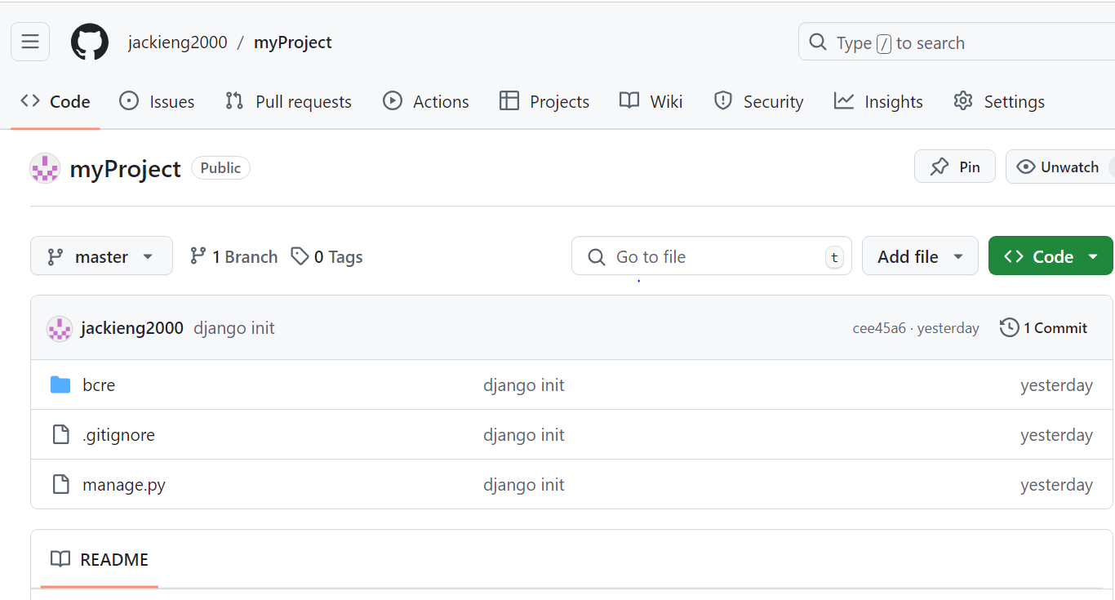

For Setting up Project Directory by Copying Code in Github

Git clone git@github.com:/jackieng2000/MyProject.git # down load the master file from github to machine
After amending code, using VScode
Git add .
Git commit –m “any message”
Git push –u origin master # update the master file to git
git log #to view the action performed

New html tab Learned
datalist
iframe
map
embed
video
audio

google analytic to analyse the rating of web pages

CSS
BreakPoint – 50 character inside container
min-width, max-width
user box-sizing: border box
- margin
position : relative, absolute
Box Model Properties

Div Flex-item
.flex-container
Flex-Direction
Flex grow

Media Queries
@media screen and (max-width: 600px){}
font-size – can be inherited from previous
rem-relative to body
em – use the latest parent
can be used vw
Use figma
@media
Issue when responsible design start design from phone layout espically nav, delete the javascript when expand

B E M
Block (main section semantic for handling media size )
Element (h2)
Modifier (class for color, font)
javascript

Immutable data type
Bigint -
number
string
boolean
undefined
null
symbol

A array four major function filter
Expression Evaluation
1) identify operator
2) precedence of operator
3) direction (from right to left)

Function
function expression // cannot be overrided
const a = function(){ }
function declaration
function b () { }
----------------------------------------------------------------------------------------------------------------------------------------
iife immediate invoke function expression // The function will not be stored in RAM after execution ( function )()
-----------------------------------------------------------------------------------------------------------------------------------------
arrow function
const a = location (b) {}
const a=(b)=>{}
const c =( ) => console.log(“Hello”);
const a=b=>{}
const d=e=>console.log(e);
d(1); //output 1
------------------------------------------------------------------------
const x=a=>b=>a+b;

const x function (a) {
return function(b) {
return {a+b};
}
}
console.log(x(1)(2));
// output 3
----------------------------------------------------------------------------------------------------------------------------------------
function a(x) { // x = b
console.log(“hello world! Function a”;
x:( )
}

function b( ) {
console.log (“function b!”);
}
a(b) //passing function into another function
----------------------------------------------------------------------------------------------------------------------------------------------------------------------
function a( ) { // x = b
console.log(“hello world! Function a”;
return b;
}

function b( ) {
console.log (“function b!”);
return a
}
a()()()()()()()() //run a then b then a then b
----------------------------------------------------------------------------------------------------------------------------------------------------------------------
I = function(x) {
return function(y) {
return x + y;
}} // define function within function to run both function
----------------------------------------------------------------------------------------------------------------------------------------------------------------------
x = 9 ) => {
let x =1;
let y = 2;
return [x,y]
}
a = x ( );
console.log(a); // output = [1,2] // return multiple value
----------------------------------------------------------------------------------------------------------------------------------------------------------------------
x = 9 ) => {
let x =1;
let y = 2;
return [x,y]
}
let [a,b] = x ( ); // de-structure the result
console.log([a, b]); // output = 1, 2 // return multiple value
----------------------------------------------------------------------------------------------------------------------------------------------------------------------

Statement
---------------------------------------------------------------------------------------------------------------------------------------
If
if ( ) { };
(1) = true
(0) = false (only this value)

x = ( ) => {console.log (“true”); return 1}
y = ( ) => {console.log (“false”); return 0}

y = (x>0) ? 1:0; // if then else structure

z = (i>0) ? x():y(); // usually use conditional expression to replace if then else
console.log(z);

z = (i>0) ? x():y() ? x() :y() //execute from left to right
------------------------------------------------------------------------------------------------------------------------------------------------------------------------
For Loop
for ( let i=1 ; I <=10; i++) {
console.log (I)
} // better use let I it will destroyed after used

let i = 1 // if not let, it will contaminate
for (; i <=10;) {
console.log(i);
i++
}
------------------------------------------------------------------------------------------------------------------------------------------------------------------------
While Loop
i = 0;
while (true) {
console.log(i++); // ++i execute it before console.log, i++ execute after
if (i===5) break
if (i===4) continue // go to top of the loop
}
-----------------------------------------------------------------------------------------------------------------------------------------------------------------------
Switch

I =0;
switch (value) {
case 10: console.log (“fail”);
break;
case 20: console.log(“fail”);
break;
case 90 : console.log(“pass”);
break;
default :
console.log(“fail”}
}

--------------------------------------------------------------------------------------------------------------------------------------------------------------------------

or
switch (true) {
case value <= 60: console.log (“fail”)
break;
case value > 60 ……

--------------------------------------------------------------------------------------------------------------------------------------------------------------------------
Truthy value

console.log(boolean(‘’)) //output false

console.log(boolean(null) //false
{} [] true
console.log([])

x = -1/0; //output Infinity
console.log(boolean(Infinity) //true

x = 0 || undefined ||null||false||NaN|| ‘’ //output NaN = false

x = 1 || 0 || undefined ||null||false||NaN|| ‘’ //output 1
-----------------------------------------------------------------------------------------------------------------------------------------------------------------------

defaultcity = “KW”;
city = ‘’
x = city || console.log(“Please input city”) || defaultcity
console.(log x)
// output Please input city KW
------------------------------------------------------------------------------------------------------------------------------------------------------------------------

Array Function

1) ForEach

each element go into the functions and out new function
companies = [
{name: "company 01", category: "retails", start: 1992, end : 2024},
{name: "company 02", category: "finance", start: 1992, end : 2024},
{name: "company 03", category: "wholes Sales", start: 1992, end : 2024},
{name: "company 04", category: "retails", start: 1992, end : 2024},
{name: "company 05", category: "retails", start: 1992, end : 2024},
{name: "company 06", category: "retails", start: 1994, end : 2024},
{name: "company 07", category: "finance", start: 1992, end : 2024},
{name: "company 08", category: "wholes Sales", start: 1992, end : 2024},
{name: "company 09", category: "retails", start: 1990, end : 2006},
{name: "company 10", category: "retails", start: 1991, end : 1997}];
const ages = [33,12,45,77,60,23,7,80,55,67,29,16];

for (let i =0; i <companies.length; i++) {console.log(companies[i]);
}

companies.forEach((company) => {console.log(company);});

// companies.forEach((company) => {
// if (company.category === "retails")
// console.log(company.name, company.end -company.start)});

ages.forEach((age,index)=> {
if (index % 2 ){
console.log(age);
age = age/2;
console.log(age);
ages[index]=age;
}
});
console.log(ages);

total = 0;
ages.forEach((age) => {
total+=age;
});
console.log(total);

2) Filter

const adult = ages.filter(age=> age > 18);
console.log(adult)

const oldWholeSales = companies.filter(company => company.category === "wholes Sales" && company.end - company.start > 10);
console.log(oldWholeSales)

3) Map old element go into new element come out give a new arrange

const companyNames = companies.map(company => [company.name, company.end - company.start]);
console.log(companyNames);

const companyNames2 = companies.map(company => `${company.name} [${company.start} ${company.end}]`);
console.log(companyNames2);

4) Reduce

the reduce() method is a powerful array method used to iterate over an array and "reduce" it to a single value. This single value can be a number, a string, an object, or even another array.

let a = [5,8,6,10,9]
let max_value = (a,b) => a > b ? a : b;
function max_seq(a) {
let result = a[0];
for (let element of a) result = max_value(result, element) ;
return result;
}
console.log((max_seq)(a));

let min_value = (a,b) => a < b ? a : b;
function min_seq(a) {
let result = a[0];
for (let element of a) result = min_value(result, element) ;
return result;
}
console.log((min_seq)(a));
let sum=(a,b) => a+b;

--------------------------------------------------------------------------------------
function reduce(x, fn, initial) {
let result = initial
for (let element of x) result = fn(result, element)
return result;
}
console.log(reduce(a,max_value, 0));
console.log(reduce(a,min_value, 0 ));
console.log(reduce(a, sum, 0);
--------------------------------------------------------------------------------------
let getSum = (total, num) => {
return total + Math.round(num);}

const numbers = [15.5, 2.3, 1.1 , 4.7];
console.log(numbers.reduce(getSum,0));
-----------------------------------------------------------------------------------------

let a = 'a'
let b = (x) => {console.log("hello world + "); return x}
console.log(b(a.repeat(8).toUpperCase().repeat(3).substring(2)))

-----------------------------------------------------------------------------------------

Bun is a fast JavaScript bundler

Vite for react template

nodejs. Webpack (use vite now to replae) vs vite

Asynchronous Function Handling

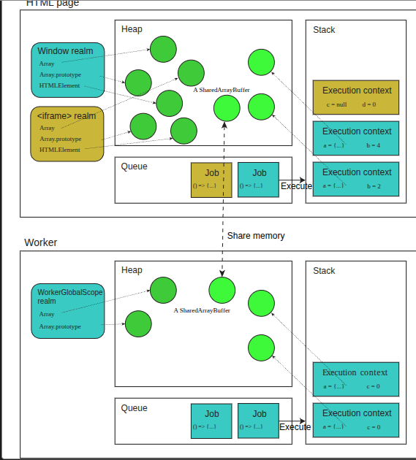

http://latentflip.com/loupe/ - JavaScript Event Model Simulator

for (var i =0; i <= 10; i++ ) {
setTimeout(() => {
console.log('loop 1 ',i);}, 10000);
}
// the output will 11 11 11 11 11 11 11 11 11 11 11 the variable still exist after execution of a loop
for (let i =0; i <= 10; i++ ) {
setTimeout(() => {
console.log( 'loop 2',i);
}, 2000);
}
// the output will 0 1 2 3 4 5 6 7 8 9 10

for (let i =0; i <= 10; i++ ) {
setTimeout(() => {
console.log( 'loop 3',i);}, 2000*i);
}
// the output will 0 1 2 3 4 5 6 7 8 9 10 with actual delay

Closure Concept

Closure is a powerful and fundamental concept that occurs when a function retains access to variables from its outer (enclosing) lexical scope, even after the outer function has finished executing.

function outer() {
let counter = 0; // Outer function's variable
function inner() {
counter++; // Inner function accesses outer variable
console.log(counter);
}
return inner; // Return the inner function
}
const increment = outer(); // outer() executes, returns inner function
increment(); // Logs: 1
increment(); // Logs: 2

Call back function
= use function as parameter of function

const a = (x) +> {
console.log (‘function a’)
x();
}
const b = () => {
console.log(‘function b’)
}
a(b) // b is the call backfunction

CSS Variable

Use variable in css

Use of emmet for easy typing in vscode

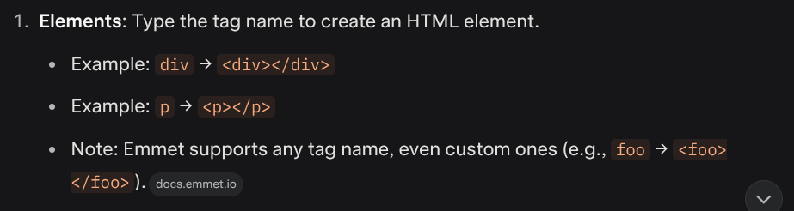

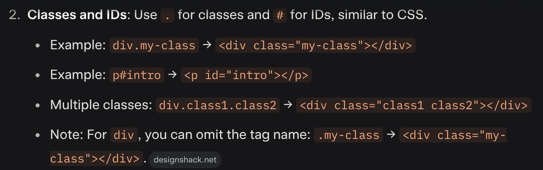

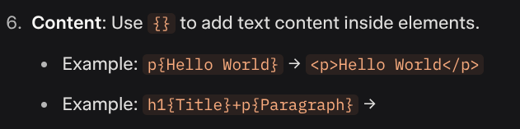

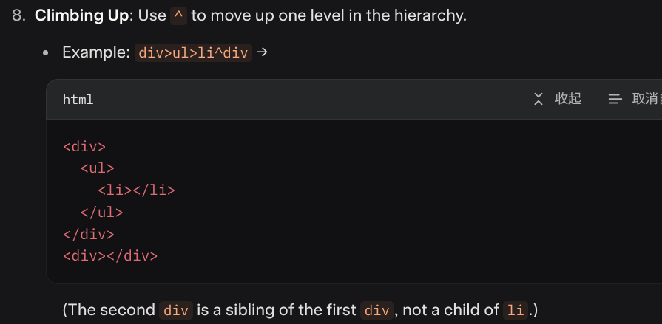

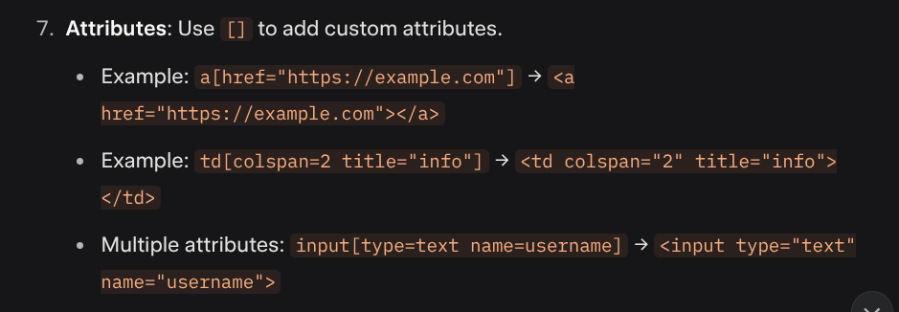

::Before & ::After

p ::before { content: ‘A’ }
for masking image, add filter

before insert before<p>, it is better to reset the margin to 0. such that no space after before

selction

